Advanced methods of Prompt Engineering
Zero shot prompts: Zero-shot prompting means asking an AI model to perform a task without giving it any examples of how to do it.
You simply describe the task, and the model tries to do it based on what it already learned during training.
Example: Classify the sentiment of this sentence:
"The movie was fantastic and I loved it."

Model Output
Positive
Here, you did not give any examples like:
- "I love this movie → Positive"
- "This movie is bad → Negative"
You just asked directly. That is zero-shot.
One Shot Prompts: A one-shot prompt means you give the AI exactly one example of how the task should be done before asking it to perform the task. So the model learns the pattern from one demonstration.

Prompt
English → Spanish
Hello → Hola
Thank you →

Output
Gracias
Here the model learns the pattern from a single example.
Few Shot Prompts: Learns from a small set of examples before tackling a similar task to generalize from a few instances to new data.
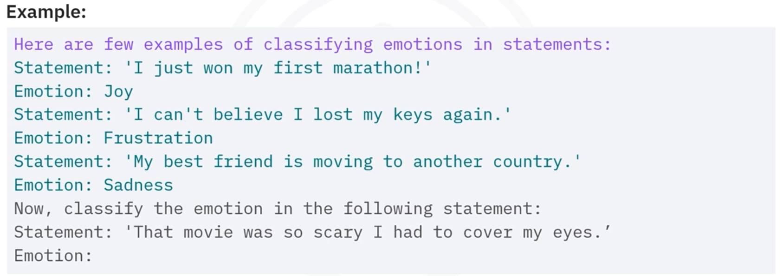

Chain-of-thought (CoT) prompting : This method is highly effective for problems requiring ​multiple intermediate steps or ​reasoning that mimics human thought processes. ​
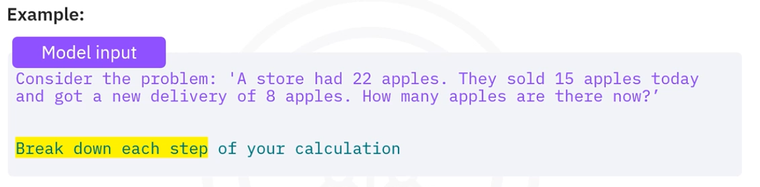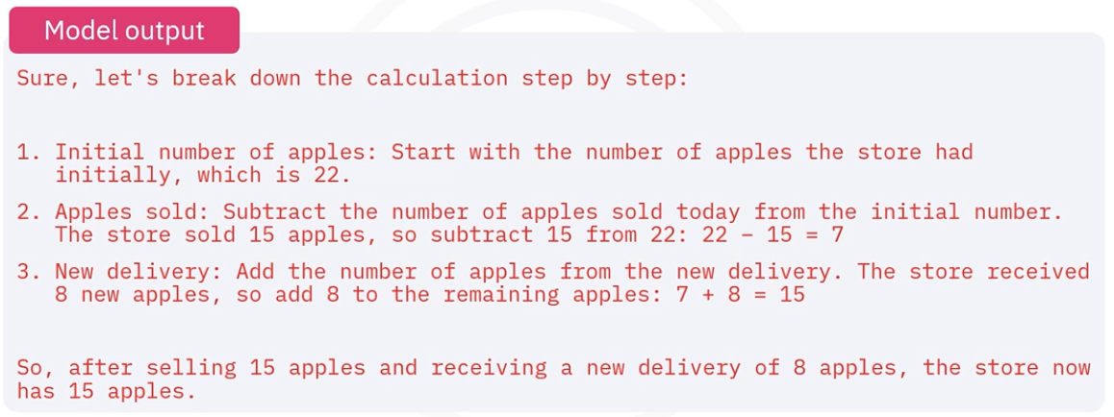

Self-Consistency : ​Self-consistency is a technique for ​enhancing the reliability and accuracy of outputs. ​It involves generating multiple independent answers to ​the same question and then evaluating ​these to determine the most consistent result.

Tools and applications used in prompt engineering.
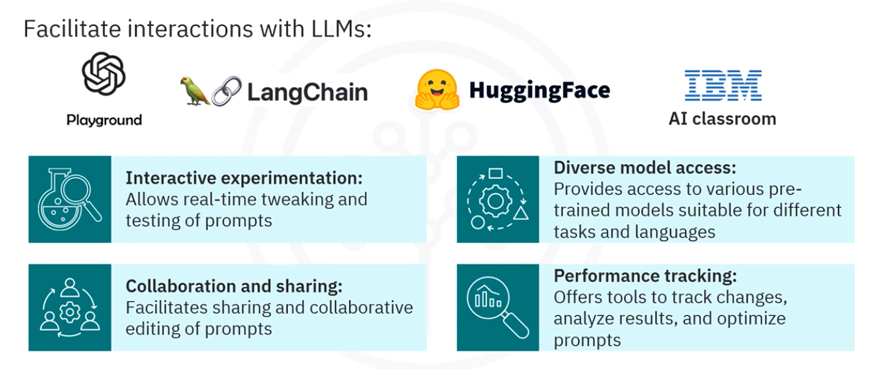

Lets learn more about LangChain a tool from prompt engineering
LangChain uses prompt templates, ​predefined recipes for generating ​effective prompt for LLMs. ​These templates include ​instructions for the language model, ​a few-shot examples to help the model ​understand contexts and expected responses, ​and a specific question directed at the language model.
LangChain is a framework used to build applications using LLMs such as OpenAI API models.
It helps developers manage things like:
- prompts
- LLM calls
- memory
- retrieval (RAG)
- chains of tasks

How LangChain Is Used in Prompt Engineering
LangChain makes prompt engineering structured, reusable, and dynamic instead of writing plain text prompts.
Without LangChain you might do this:
prompt = "Translate this sentence to French: I love programming"
But in real applications, prompts need to be dynamic and reusable.
LangChain helps with that.

Prompt Templates (Most Important)
LangChain has something called PromptTemplate.
It lets you create parameterized prompts.
Example:
​Here is a code snippet to ​apply a prompt template from LangChain.
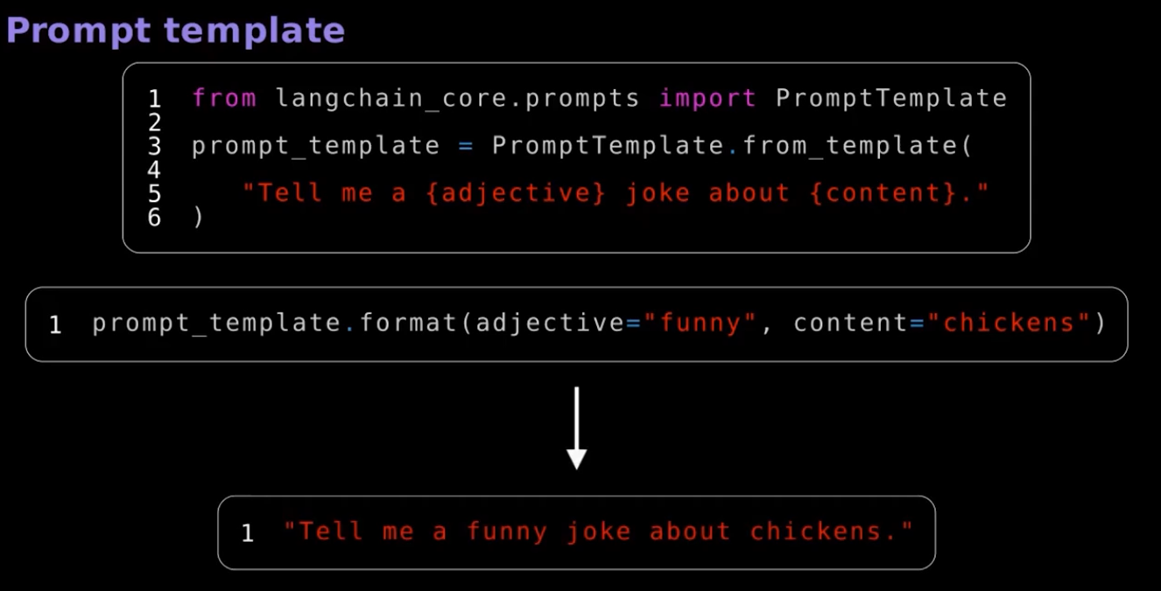
​First, import the prompt template ​from LangChain core prompts. ​Then define a joke prompt template, ​tell me a joke about. ​This template has placeholders ​for an adjective and the content. ​To use the template, call prompt template format with ​specific values funny for ​the adjective and chickens for the content. ​This generates the prompt, ​tell me a funny joke about chickens. ​This approach simplifies prompt creation, ​making prompt consistent and ​adaptable to different contexts.

